Ergo C 200™
Standard [ERGO C 200 STANDARD FR (PU)]
Backrest  - Dual Curve Polyurethane Backrest  - 15" wide by 13" high  Arms  - Click here to view options  Seat  - Polyurethane Foam  - Seat Pan 19" wide by 18" deep  Options:  - -Raised pattern design for both seat and backrest reduces slippage for additional safety. Backrest has a handle for easy maneuvering of the chair [RP]  Standard Mechanism  - Back Angle Adjustment  - Back Height Adjustment  - Back Pivot  Pneumatic Lift (Seat Height)  - 200 mm pneumatic lift (18.5"-25.5")  Options:  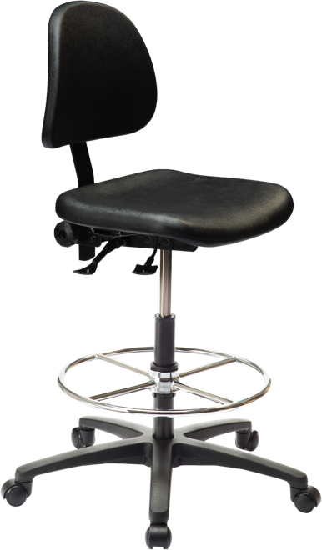  - 267 mm pneumatic lift (21"-31") [267mm] | Base/Glides/Casters  - 1 1/4" Glides  - 26" Glass Reinforced Nylon Base  - 20" Diameter Height Adjustable Footring (for use as a foot rest only)  Options:  - 2 1/4" Glides (adds 1" to seat height) [2G]  - Single Wheel Urethane Casters (adds 1" to seat height) [SWU]  - Nylon Casters (adds 1" to seat height) [NC]  - Urethane Casters (adds 1" to seat height) [UC]  - Lock-on Urethane Casters (adds 1" to seat height) [LON]  - Single Wheel Casters (adds 1" to seat height) [SW]  - Lock-off Urethane Casters (adds 1" to seat height) [LOF]  Upholstery  - Available in vinyl, fabric or ergoCentric+Guard  Additional Options  - Back Trim [BT]  - Cal. 133 [Cal133]  - Anti Static  (Available in fabric  and vinyl only)  [ANTISTATIC]  - Class 100 Cleanroom  (only available in vinyl)  [CRPACK]  - Height Adjustable Footring [ERGOFR]

