Spider Sit Stand
[SPIDER SIT STAND]
Seat  - Adjustable Spring Tension  - Infinite Lock Tilting Seat Pan  - Upholstered sit stand seat (17.5" w x 15.5" d)  Options:  - ergoCentric+Guard Sealed Seat (includes under seat pan) [EGUSS]  Pneumatic Lift (Seat Height)  - 200 mm Knurled Pneumatic Lift, Dual Height Adjustment System (seat height 7.5" of adjustment between 21"-33.5")  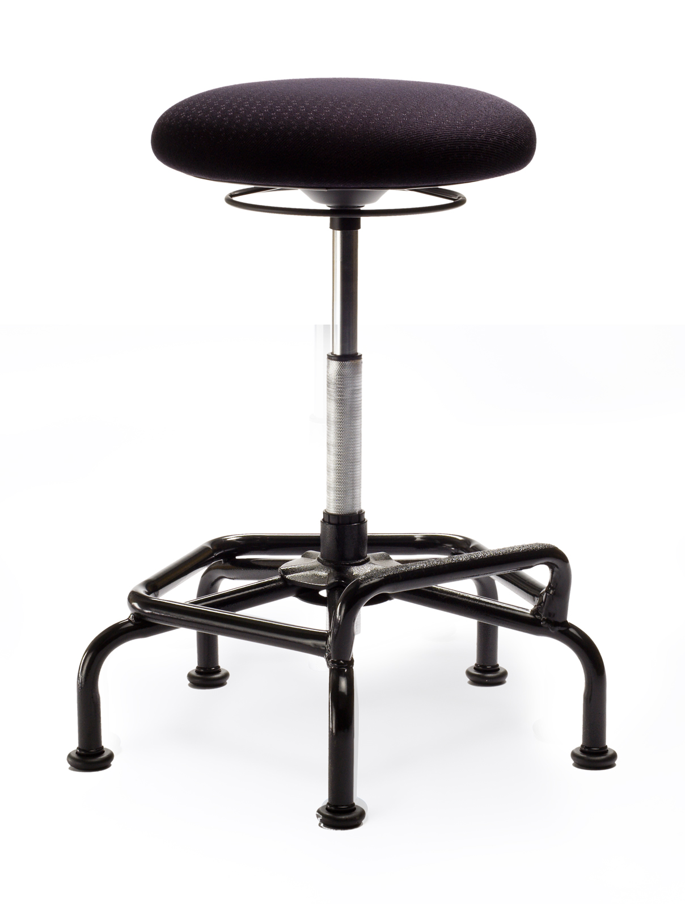 | Base/Glides/Casters  - 1/2" Industrial Glides  - 22 Bi-Level Spider Base has highly durable anti-scuff textured powder coating and embossed steel treads on footrests  - Footrest 7", 9.5" high  Options:  - 22" Chrome 22 Base has an 18" oval tube footring built in for durability [C22]  - Lock-on Urethane Casters (adds 1.5" to seat height) [LON]  - 2 1/4" Glides (adds 1.5" to seat height) [2G]  Additional Options  - 6" ergoCentric+Guard No Slip Strip on front of seat [ANTSPU]  - Cal. 133 [Cal133]  - Anti Static (Available in fabric and vinyl only) [ANTISTATIC]  - Height Adjustable Footring [ERGOFR]

