airCentric™2
Counter Height* | Midnight Black [air2-CH/air2S-CH]
 | Light Grey [air2-CHG/air2S-CHG]
Backrest:  Midnight Black / Light Grey  - 5" Patented Back Height Adjustment System  - Plastic Back Cap with Airflow Vents [air2]  - Solid Back Cap [air2S]  - Proprietary Airflow Molded Polyurethane Foam and Structure  - Front Upholstered Dual Curve Backrest (19"w x 24"h)  Arms:  Midnight Black / Light Grey [G]  Options:  - tCentric Armrest Height & Lateral [TCL / TCLG]  - tCentric Armrest Height & Swivel [TC360 / TC360G]  - tCentric Armrest Height, Lateral & Swivel [TCL360 / TCL360G]  Seat:  - Dual Density Molded Polyurethane Foam  - Eight Ply Hardwood Seat Structure Seat Pan (20”w x 19”d)  - Tailored Upholstery on Seat Pan  Options:  - Extra Small (17 ½”w x 15 ½d) [XSS]  - Small Seat (18 ½”w x 17”d) [SS]  - Standard Seat (20”w x 19”d) [LS]  - Plus Size (22”w x 19”d) [PS]  - Extra Long Seat (20”w x 21”d) [XLS]  - Triple Density Foam (adds ¼” to seat width & depth) [TDF]  - Non-Tailored Seat Pan [NTS]  Pneumatic Lift (Seat Height):  Midnight Black / Light Grey  - 200 mm Pneumatic Lift (23 ½” – 30 ¾")  Options:  Midnight Black / Light Grey [G]  - 157 mm Pneumatic Lift (19 ¾” - 25 ½”) [157MM/G157MM]  - 267 mm Pneumatic Lift (25 ¾” – 35 ¾”) [267MM/G267MM] | Counter Height Mechanism:  - Independent Back Angle Adjustment  - Fixed Seat  - Seat Height  Base/Glides/Casters:  Midnight Black/Light Grey  - 26" Glass Reinforced Nylon Mid Profile Base  - 20” Diameter Aluminum, Height Adjustable Footring (1 ¾” foot platform)  - 1 ¼” Glides  Options:  - Lock-on Urethane Casters [LON]  - Lock-off Urethane Casters [LOF]  - Single Wheel Nylon Casters [SW]  - Single Wheel Urethane Casters [SWU]  - Dual Wheel Nylon Casters [NC]  - Dual Wheel Urethane Casters [UC]  - 2 ¼” Glides [2G]  Additional Options:  - Modified Multi Tilt Mechanism [MT]  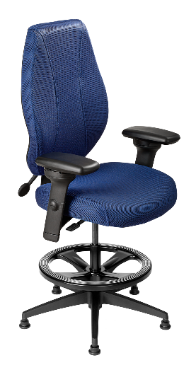  - Dedicated Task 2 Mechanism [DT2]  Measurements:  Boxed Weight / Size  - 56 lbs. / 11.7 cu. ft.  *Mixing of Midnight Black & Light Grey components is not an option.

