airCentric™2
Synchro Glide | Midnight Black [air2-SG]
 | Light Grey [air2-SGG]
Mixing of Midnight Black & Light Grey components is not an option.
Backrest  - 5" Patented Back Height Adjustment System  - Front Upholstered Dual Curve Backrest (19"w x 24"h)  - Plastic Back Cap with Airflow Vents  (Light Grey / Midnight Black)  - Proprietary Airflow Molded Polyurethane Foam and Structure  Arms (Midnight Black / Light Grey)  - Click here to view options  Seat  - Tailored Upholstery on Seat Pan (20”w x 19”d)  - Proprietary Airflow Molded Polyurethane Foam and Structure  Options:  - Extra Small (17.5”w x 15.5d) [XSS]  - Small Seat (18.5”w x 17”d) [SS]  - Plus Size (18.”w x 19”d) [PS]  - Extra Long Seat (20”w x 21”d) [XLS]  - Standard Seat (20”w x 19”d) [LS]  - Triple Density Foam (adds ¼” to seat width and depth) [TDF]  Pneumatic Lift (Seat Height)  (Midnight Black / Light Grey)  - 125 mm Pneumatic Lift (18" – 23")  Options:  Midnight Black  - 80 mm Pneumatic Lift (only available with 26” Glass Reinforced Nylon Base) (17.25”-20.25”) [80mm]  - 100 mm Pneumatic Lift (17.5”-21”) [100mm]  - 140 mm Pneumatic Lift (19”-24.5”) [140mm]  Light Grey  - 80 mm Pneumatic Lift (only available with 26” Glass Reinforced Nylon Base) (17.25”-20.25”) [G80mm]  - 100 mm Pneumatic Lift (17.5”-21”) [G100mm]  - 140 mm Pneumatic Lift (19”-24.5”) [G140mm] |  | Synchro Glide Mechanism  (Midnight Black / Light Grey)  - 2.5” Depth Adjustable Seat Slider  - Adjustable Spring Tension  - Free Float  - Independent Back Angle Adjustment  - Seat Tilt Lock Out  - Synchro 2:1 Ratio  Base/Glides/Casters  Midnight Black  - 26" Glass Reinforced Nylon Mid Profile Base  - 5 Dual Wheel Nylon Carpet Casters  Light Grey  - Light Grey 26" Glass Reinforced Nylon Mid Profile Base  - 5 Dual wheel nylon casters 2  Options:  - 2 ¼” Glides [2G]  - Chrome Accent Casters [CAC]  - 26” Polished Aluminum Base [PB]  - Single Wheel Casters [SW]  - Single Wheel Urethane Casters [SWU]  - Urethane Casters [UC]  Midnight Black  - 26” Glass Reinforced Nylon Base [26NB]  - 26” Glass Reinforced High Profile Nylon Base [26HP2]  Additional Options  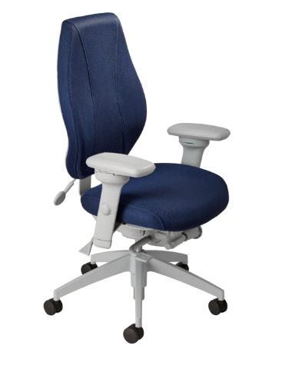  - Memory Foam Seat (Not Available on airCentric seat options) [EA]  - Cal. 133 [Cal133]  Midnight Black  - Air Lumbar [AL]  - Adjustable Headrest [AHRTS]  Light Grey  - Air Lumbar [ALG]  - Adjustable Headrest [AHRTSG]

