airCentric™2
Synchro Glide* | Midnight Black [air2-SG/air2S-SG]
 | Light Grey [air2-SGG/air2S-SGG]
Backrest:  Midnight Black / Light Grey  - 5" Patented Back Height Adjustment System  - Plastic Back Cap with Airflow Vents [air2]  - Solid Back Cap [air2S]  - Proprietary Airflow Molded Polyurethane Foam and Structure  - Front Upholstered Dual Curve Backrest (19"w x 24"h)  Arms:  Midnight Black / Light Grey [G]  Options:  - tCentric Armrest Height & Lateral [TCL / TCLG]  - tCentric Armrest Height & Swivel [TC360 / TC360G]  - tCentric Armrest Height, Lateral & Swivel [TCL360 / TCL360G]  Seat:  - Dual Density Molded Polyurethane Foam  - Eight Ply Hardwood Seat Structure Seat Pan (20”w x 19”d)  - Tailored Upholstery on Seat Pan  Options:  - Extra Small (17 ½”w x 15 ½d) [XSS]  - Small Seat (18 ½”w x 17”d) [SS]  - Standard Seat (20”w x 19”d) [LS]  - Plus Size (22”w x 19”d) [PS]  - Extra Long Seat (20”w x 21”d) [XLS]  - Energy Absorbent Memory Foam [EA]  - Triple Density Foam (adds ¼” to seat width & depth) [TDF]  - Non-Tailored Seat Pan [NTS]  Pneumatic Lift (Seat Height):  Midnight Black / Light Grey  - 125 mm Pneumatic Lift (18" – 23")  Options:  Midnight Black / Light Grey [G]  - 80 mm Pneumatic Lift (only available with 26” Glass Reinforced Nylon Base) (17 ¼”-20 ¼”) [80MM/G80MM]  - 100 mm Pneumatic Lift (17 ½”-21”) [100MM/G100MM]  - 140 mm Pneumatic Lift (19”-24 ½”) [140MM/G140MM] | Synchro Glide Mechanism:  Midnight Black / Light Grey  - Seat Tilt Lock Out  - Free Float  - Independent Back Angle Adjustment  - Synchro 2:1 Ratio  - Adjustable Spring Tension  - 2 ½” Depth Adjustable Seat Slider  Base/Glides/Casters:  Midnight Black  - 26" Glass Reinforced Nylon High Profile Base  - 5 Dual Wheel Nylon Carpet Casters  Light Grey  - 26" Glass Reinforced Nylon High Profile Base  - 5 Dual Wheel Nylon Casters 2  Options:  Midnight Black / Light Grey  - 26” Polished Aluminum Base [26PB]  - Chrome Accent Casters [CAC]  - Urethane Casters [UC]  - Single Wheel Casters [SW]  - Single Wheel Urethane Casters [SWU]  - 2 ¼” Glides [2G]  Midnight Black  - 26” Glass Reinforced Nylon Base [26NB]  - 26” Glass Reinforced High Profile Nylon Base [26MP]  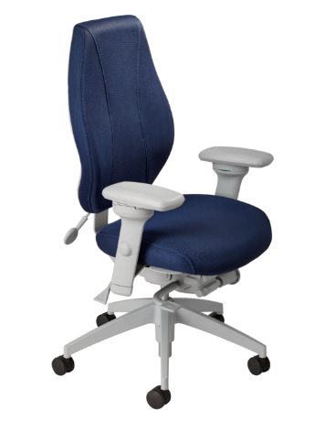  Additional Options:  Midnight Black / Light Grey [G]  - Air Lumbar [AL/ALG]  - Air Thoracic [AT/ATG]  - Tailored Adjustable Headrest [AHR/AHRG]  Measurements:  Boxed Weight / Size  - 56 lbs. / 11.7 cu. ft.  *Mixing of Midnight Black & Light Grey components is not an option.

