ecoCentric Stacker
With Arms [eco-STACKER-A]
Backrest  - Backrest 20" wide by 12.5" high  - Dual curve plastic backrest  - Handle in back for easy movement  - Unique scalloped indentations for the spine provides additional comfort  Options:  - Upholstered Back [UPHB]  Arms  - Tablet Arm  Options:  - Padded Nytek Arm Cover (Permanent Cover) [PNY]  Seat  - 17" Seat Height  - Dual Curve Waterfall Plastic Seat in Black  - Seat Pan 18" wide by 18.5" deep  - Unique Scalloped Indentations for the Seat Bones  Options:  - Grey Package (Includes grey seat, backrest and arm caps) [ECOGP]  - Upholstered Seat [UPHS] | Base/Glides/Casters  Options:  - Nylon Stacker Casters [NSC]  - Urethane Stacker Casters [USC]  - Metal Sled base option with glass reinforced nylon glides (chair does not stack with sled base option) [SLED]  Frame  - 14 Gauge, 7/8" Steel Tube Frame  - Black Textured Semi-Gloss Powder Coat Paint  - Glass filled nylon arms (black)  - Kick Back Legs for Stability with Durable Custom Glides  Options  - Wall saver frame (WSF)  Additional Options  - Grey Arm Cap [GAC]  - Grey Plastic Backrest (20”w x 12.5”d) [PLABG]  - Grey Plastic Seat (18”w x 18.5”d) [PLASG]  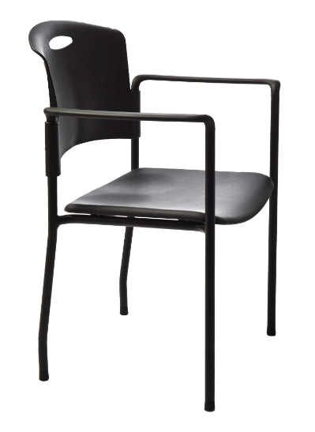  - Ganging clips (set of 2) chair with arms [GC]

