ergoForce High Back
24 Hour Multi Tilt [eForce-HB-24MT]
Backrest  - 5" Patented Back Height Adjustment System  - Abrasion resistant strip on bottom of backrest 7” high  - Fully Upholstered Dual Curved Backrest (19” w x 26” h)  - Heavy Duty Back Bar Support  - Molded Polyurethane Foam  Arms  - Click here to view options  Seat  - Abrasion resistant strip on back of seat  - Eight Ply Hardwood Seat Structure  - High Resilient Polyurethane Foam  - Seat Pan 20" wide by 19" deep  Options:  - Extra Long Seat (20"Wx21"D) [XLS]  - Small Seat (18.5"Wx17"D) [SS]  - Triple Density Foam Seat (Adds 1/4" to seat width and depth) [TDF]  - Tailored Upholstery on Seat Pan [TS]  24 Hour Multi Tilt Control  - Back Angle Adjustment  - Adjustable Spring Tension  - Forward Tilt Lock Out  - Infinite Lock Free Float  - 2.5” Depth Adjustable Seat Slider  Pneumatic Lift (Seat Height)  - 125 mm Pneumatic Lift (seat height -17.5"-22.5")  Options:  - 80 mm pneumatic lift (17"-20") [80mm]  - 100 mm pneumatic lift (17.25-20.75") [100mm]  - 140 mm pneumatic lift (18"-23.5") [140mm] | Base/Glides/Casters  - 5 Dual Wheel Nylon Carpet Casters  - 26” Glass Reinforced Nylon Base  Options:  - 2 1/4" Glides [2G]  - Chrome Accent Casters [CAC]  - Single Wheel Casters [SW]  - Single Wheel Urethane Casters [SWU]  - Urethane Casters [UC]  Additional Options  - Air Lumbar [AL]  - Air Thoracic [AT]  - Air Thoracic and Air Lumbar [ATL]  - Adjustable Headrest [AHR]  - Heavy Duty Control (Task Intensive) [TI]  Additional Options  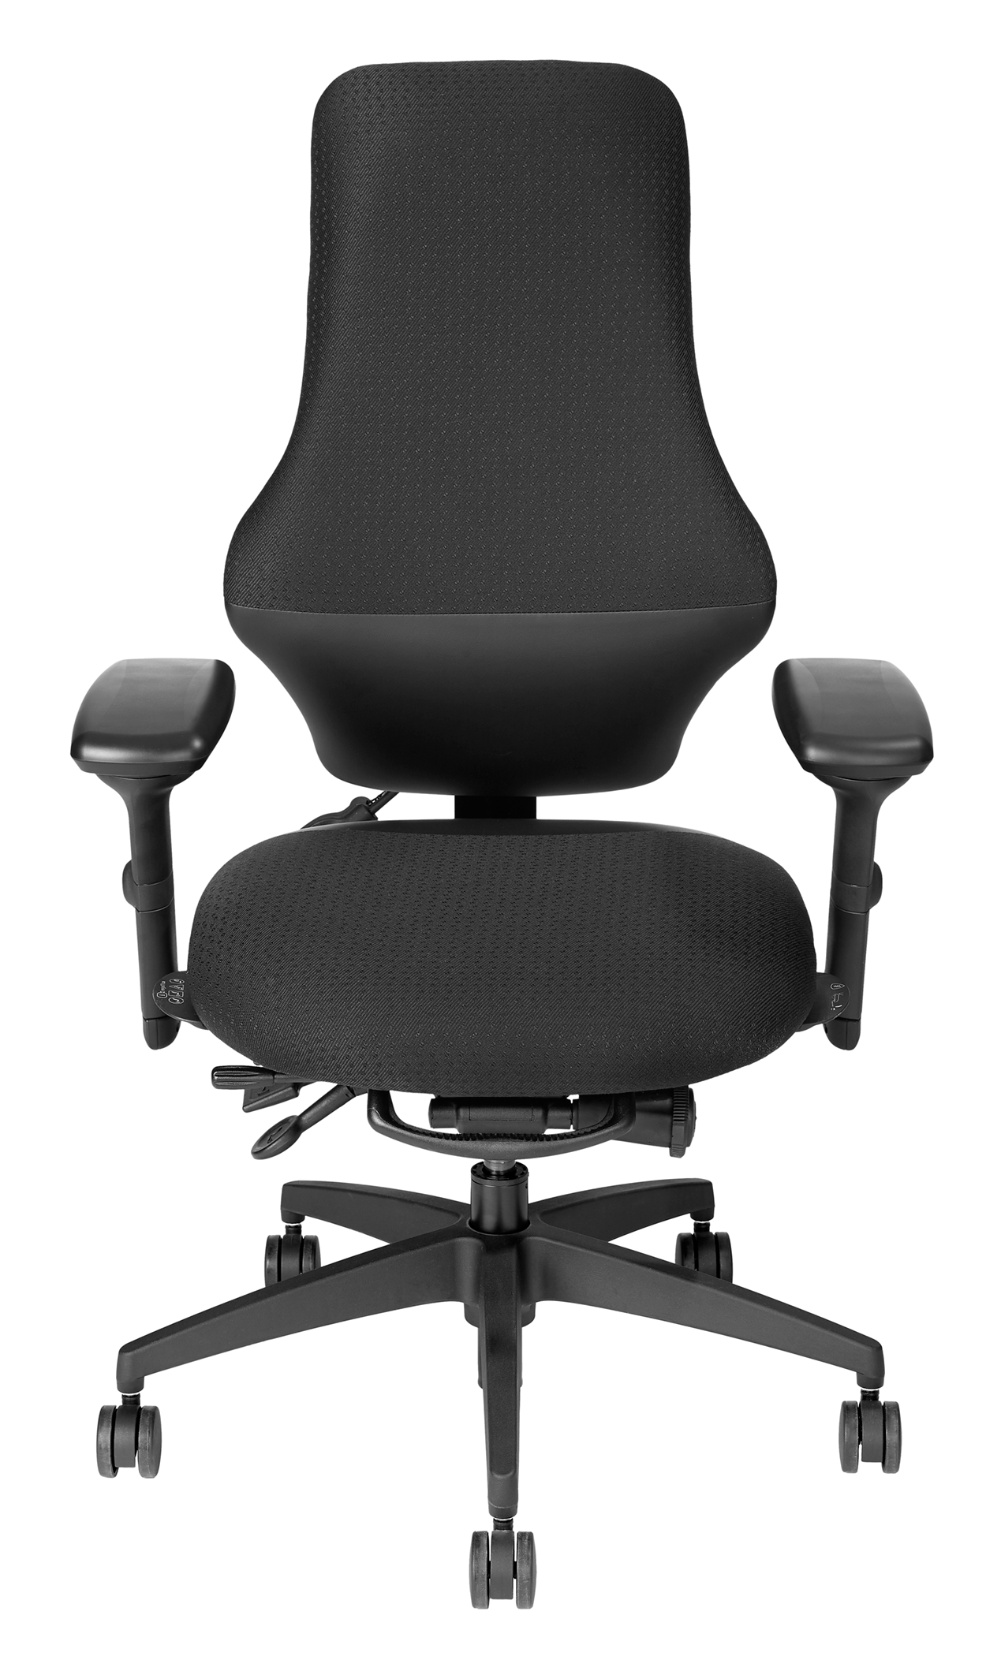  - Boxed Weight / Size 72 lbs./11.7 cu.ft

