geoCentric™
Counter Height Series | Mid Back [geo-MB-CH]
Backrest:  - 5" Patented Back Height Adjustment System  - Fully Upholstered Dual Curve Backrest (17”w x 19”h)  Arms:  Options:  - 4” Height Adjustable Arm [4ATAOT]  - 3” Height Adjustable Arm [3ATAOT]  - 4” Height Adjustable Swivel Arm [SWV]  Seat:  - Dual Density Molded Polyurethane Foam  - Eight Ply Hardwood Seat Structure Seat Pan (20”w x 19”d)  - Tailored Upholstery on Seat Pan  Options:  - Extra Small (17 ½”w x 15 ½d) [XSS]  - Small Seat (18 ½”w x 17”d) [SS]  - Standard Seat (20”w x 19”d) [LS]  - Plus Size (22”w x 19”d) [PS]  - Extra Long Seat (20”w x 21”d) [XLS]  - Energy Absorbent Memory Foam [EA]  - Triple Density Foam (adds ¼” to seat width & depth) [TDF]  - Non-Tailored Seat Pan [NTS]  Pneumatic Lift (Seat Height):  - 200 mm Pneumatic Lift (23 ½” – 30 ¾”)  Options:  - 157 mm Pneumatic Lift (19 ¾”-25 ½”) [157MM]  - 267 mm Pneumatic Lift (25 ¾”- 35 ¾”) [267MM]  Counter Height Mechanism:  - Independent Back Angle Adjustment  - Fixed Seat  - Seat Height | Base/Glides/Casters:  - 26" Glass Reinforced Nylon Mid Profile Base  - 20” Diameter Aluminum, Height Adjustable Footring; 1 ¾” Foot Platform  - 1 ¼” Glides  Options:  - Lock-on Urethane Casters [LON]  - Lock-off Urethane Casters [LOF]  - Dual Wheel Nylon Casters [NC]  - Dual Wheel Urethane Casters [UC]  - Single Wheel Casters [SW]  - Single Wheel Urethane Casters [SWU]  - 2 ¼” Glides [2G]  Additional Options:  - Air Lumbar [AL]  - Air Thoracic [AT]  - Adjustable Headrest [AHR]  - Thoracic Back Support [THB]  - Plastic Back Cap – Fabric [PBCMBF]  - Dedicated Task Mechanism [DT2]  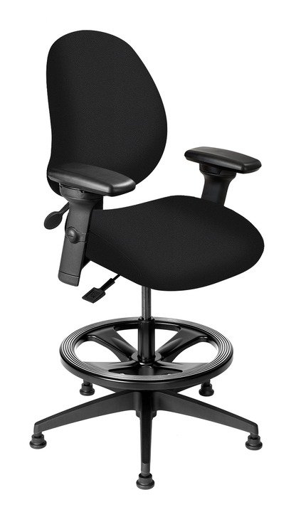  Measurements:  Boxed Weight / Size  - 52 lbs. / 6.7 cu. ft.

