geoCentric™
Dedicated Task Series | Mid Back [geo-MB-DT2]
Backrest  - 5" Patented Back Height Adjustment System  - Fully Upholstered Dual Curve Backrest (17”w x 19”h)  Arms  Options:  - 4” Height Adjustable Arm [4ATAOT]  - 3” Height Adjustable Arm [3ATAOT]  Seat  - Dual Density Molded Polyurethane Foam  - Eight Ply Hardwood Seat Structure Seat Pan (20”w x 19”d)  - Tailored Upholstery on Seat Pan  Options:  - Extra Small (17 ½”w x 15 ½d) [XSS]  - Small Seat (18 ½”w x 17”d) [SS]  - Standard Seat (20”w x 19”d) [LS]  - Plus Size (22”w x 19”d) [PS]  - Extra Long Seat (20”w x 21”d) [XLS]  - Energy Absorbent Memory Foam [EA]  - Triple Density Foam (adds ¼” to seat width & depth) [TDF]  - 2 ½” Seat Slider (adds 1 ½” to seat height) [SSLF]  - Tailored Upholstery on Seat Pan [TS]  - Non-Tailored Seat Pan [NTS]  Pneumatic Lift (Seat Height)  - 125 mmLT Pneumatic Lift (15 ½” – 20 ½”)  Options:  - 70 mm Pneumatic Lift (15”- 17 ¾”) [70MM]  - 80 mm Pneumatic Lift (15 ¾” – 18 ½”) [80MM]  - 100 mm Pneumatic Lift (16 ¼”-20”) [100MM]  - 140 mm Pneumatic Lift (17 ½”- 23 ¾”) [140MM]  - 157 mm Pneumatic Lift (19 ¾” – 25 ½”) [157MM]  - 200 mm Pneumatic Lift (23 ½” – 30 ¾”) Glides recommended [200MM]  - 267 mm Pneumatic Lift (25 ¾” – 35 ¾”) Glides recommended [267MM] | Dedicated Task 2 Mechanism  - Independent Back Angle Adjustment  - Seat Angle Adjustment  - Seat Height  Base/Glides/Casters  - 26" Glass Reinforced Nylon Mid Profile Base  - 5 Dual Wheel Nylon Casters  Options:  - Chrome Accent Casters [CAC]  - Dual Wheel Urethane Casters [UC]  - Single Wheel Casters [SW]  - Single Wheel Urethane Casters [SWU]  - 2 ¼” Glides [2G]  Additional Options  - Air Lumbar [AL]  - Air Thoracic [AT]  - Adjustable Headrest [AHR]  - Thoracic Back Support [THB]  - Plastic Back Cap – Fabric [PBCMBF]  - 20” Diameter Height Adjustable Footring (Used as a footrest on 200mm and 267mm lifts only)  Measurements  Boxed Weight / Size  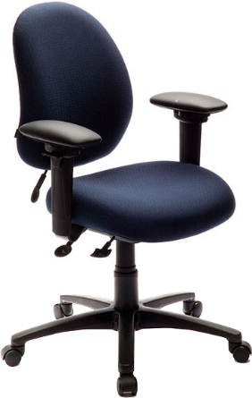  - 42 lbs. / 6.7 cu. ft.

