tCentric Hybrid™
Accent | Midnight Black [t-ACCENT]
Backrest  - 5" Patented Back Height Adjustment System  - Dual Curve Mesh Backrest (19"w x 25"h)  Arms  - Click here to view options  Seat  - Dual Density Molded Polyurethane Foam  - Eight ply hardwood seat structure  - Tailored upholstery on seat pan (20”w x 19”d)  Options:  - Extra Small Seat (17.5”w x 15.5”d) [XSS]  - Small Seat (18.5”w x 17”d) [SS]  - Plus Size Seat (22”w x 19”d) [PS]  - Extra Long Seat (20”w x 21”d) [XLS]  - Extra Deep Seat (22”w x 21”d) [XPS]  Pneumatic Lift (Seat Height)  - 125 mm Pneumatic Lift (17.25" – 22")  Options:  Midnight Black  - 80 mm Pneumatic Lift (16.5”-19.5”) [80mm]  - 100 mm Pneumatic Lift (17”-20.75”) [100mm]  - 140 mm Pneumatic Lift (18.25”-23.75”) [140mm]  Chrome  - 100 mm Chrome Pneumatic Lift (17.5”-21”) [100mmCH]  - 125 mm Chrome Pneumatic Lift (17.25" – 22") [125mmCH]  - 140 mm Chrome Pneumatic Lift (18.25”-23.75”) [140mmCH] |  | Accent Mechanism  - Adjustable Spring Tension  - Seat Height  - Infinite Lock Free Float  Base/Glides/Casters  Midnight Black  - 26" Glass reinforced nylon high profile base  - 5 Dual wheel nylon casters 2  Options:  - Energy Absorbant Memory Foam [EA]  - Triple Density Foam [TDF]  - Non-Tailored Seat Pan [NTS]  - Chrome Accent Casters [CAC]  - 26” Polished Aluminum Base [26PB2]  - Dual Wheel Urethane Caster 2 [UC2]  Additional Options  Midnight Black  - Lumbar Support [TLS]  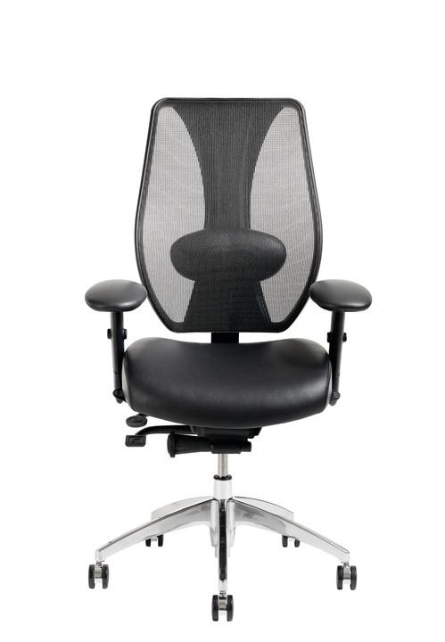  - Air Lumbar [TLSAL]  - Adjustable Headrest [AHRTS]

