tCentric Hybrid™
All Mesh – Boardroom* | Midnight Black [t-MBMESH-BR]
 | Light Grey [t-LGMESH-BRG]
Backrest:  - 5" Patented Back Height Adjustment System  - Dual Curve Mesh Backrest (19"w x 25"h)  Arms:  Midnight Black / Light Grey [G]  - TC Armrest Height & Lateral [TCL / TCLG]  - TC Armrest Height & Swivel [TC360 / TC360G]  - TC Armrest Height, Lateral & Swivel [TCL360 / TCL360G]  Seat:  Midnight Black / Light Grey  - Airless Cushion Technology  - Mesh Seat with 30% Glass Filled Nylon Frame  (21”w x 18 ½”d)  Options:  Midnight Black [MB] / Light Grey [G]  - Small Mesh Seat (20”w x 16 ½”d) [TMBMSS / TLGMSS]  - Extra Long Mesh Seat (21”w x 20 ½”d) [TMBMXLS / TLGMXLS]  Pneumatic Lift (Seat Height):  Midnight Black / Light Grey  - 125 mm Pneumatic Lift (16 ¾" – 21 ¾")  Options:  Midnight Black / Light Grey [G]  - 140 mm Pneumatic Lift (18 ¾”-25”) [140MM/G140MM]  Chrome  - 125 mm Chrome Pneumatic Lift (18”-23”) [125MMCH]  - 140 mm Chrome Pneumatic Lift (19”-24.5”) [140MMCH]  Boardroom Mechanism:  Midnight Black / Light Grey  - Single Lock Free Float  - Seat Height  - Adjustable Spring Tension  Base/Glides/Casters:  Midnight Black  - 26" Glass Reinforced Nylon Mid Profile Base  - 5 Dual Wheel Nylon Casters 2 |  | Light Grey  - 26" Glass Reinforced Nylon Mid-Profile Base  - 5 Dual Wheel Nylon Casters 2  Options:  - Chrome Accent Casters [CAC]  - 26” Polished Aluminum Mid-Profile Base [PMB]  - Dual Wheel Urethane Caster 2 [UC2]  Additional Options:  Midnight Black / Light Grey [G]  - tCentric Lumbar Support [TLS / TLSG]  - tCentric Lumbar Support with Air Lumbar (pump) [TLSAL / TLSALG]  - Adjustable Headrest [AHR / AHRG]  Measurements/Overall Dimensions:  - Boxed Weight/Size: 46.4 lbs. / 11.7 cu.ft.  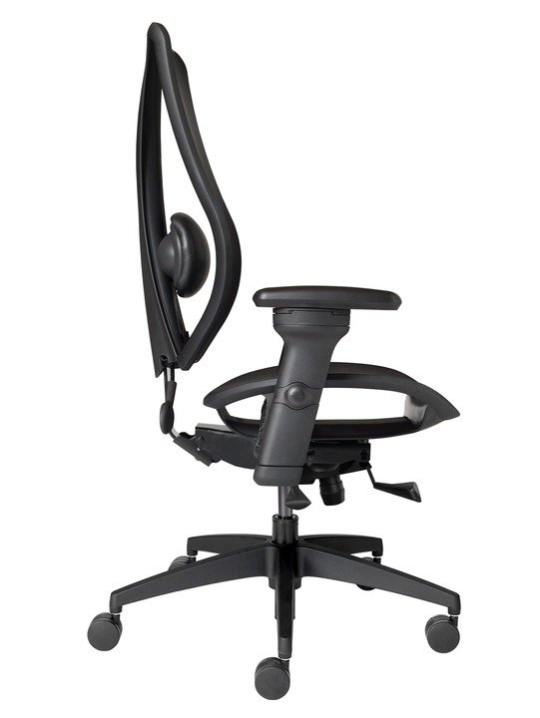  Mesh Material  Both the tCentric Hybrid seat and backrest are made from elastomeric mesh with fill yarns made from polyester.  When stretched, this material yields excellent load-bearing properties and resiliency, showing less than 5% load-bearing loss when tested according to BIFMA standards.  To clean use mild household or hospital detergents.  * Mixing of Midnight Black & Light Grey components is not an option.

