tCentric Hybrid™
All Mesh – Counter Height* |  | Midnight Black [t-MBMESH-CH]
 |  | Light Grey [t-LGMESH-CHG]
Backrest:  Midnight Black / Light Grey  - 5" Patented Back Height Adjustment System  - Dual Curve Mesh Backrest (19"w x 25"h)  Arms:  Midnight Black / Light Grey [G]  Options:  - tCentric Armrest Height & Lateral [TCL / TCLG]  - tCentric Armrest Height & Swivel [TC360 / TC360G]  - tCentric Armrest Height, Lateral & Swivel [TCL360 / TCL360G]  Seat:  Midnight Black / Light Grey  - Airless Cushion Technology  - Mesh Seat with 30% Glass Filled Nylon Frame (21”w x 18 ½”d)  Options:  Midnight Black [MB] / Light Grey [G]  - Small Mesh Seat (20”w x 16 ½”d) [TMBMSS / TLGMSS]  - Extra Long Mesh Seat (21”w x 20 ½”d) [TMBMXLS / TLGMXLS]  Counter Height Mechanism:  Midnight Black / Light Grey  - Independent Back Angle Adjustment  - Fixed Seat  - Seat Height  Options:  Midnight Black  - Multi-Tilt (with height and back angle adjustment) [MT]  - Dedicated Task 2 Mechanism [DT2]  Pneumatic Lift (Seat Height):  Midnight Black / Light Grey  - 200 mm Pneumatic Lift (24 ¾" - 32")  Options:  Midnight Black / Light Grey [G]  - 157 mm Pneumatic Lift (24 ¾” – 32”) [157MM/G157MM]  - 267 mm Pneumatic Lift (27”-37”) [267MM/G267MM]  Measurements/Overall Dimensions:  - Boxed Weight/Size: 56 lbs. / 6.7 cu.ft. | Base/Footring/Glides/Casters:  - 26" Glass Reinforced Nylon Mid-Profile Base (Midnight Black / Light Grey)  - Aluminum, Height Adjustable Footring (20” Diameter, 1 ¾” Thick Foot Platform)  - 1 ¼” Glides  Options:  - Lock-on Urethane Casters [LON]  - Lock-off Urethane Casters [LOF]  - Dual Wheel Urethane Casters [UC]  - Dual Wheel Nylon Casters [NC]  - Single Wheel Urethane Casters [SWU]  - Single Wheel Nylon Casters [SW]  - 2 ¼” Glides  Additional Options:  Midnight Black / Light Grey [G]  - tCentric Lumbar Support [TLS / TLSG]  - tCentric Lumbar Support with Air Lumbar (pump) [TLSAL / TLSALG]  - Adjustable Headrest [AHR / AHRG]  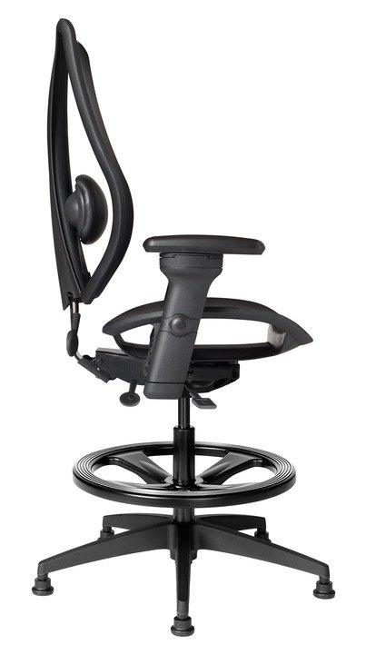  Mesh Material:  Both the tCentric Hybrid seat and backrest are made from elastomeric mesh with fill yarns made from polyester.  When stretched, this material yields excellent load-bearing properties and resiliency, showing less than 5% load-bearing loss when tested according to BIFMA standards.  To clean use mild household or hospital detergents.  *Mixing of Midnight Black & Light Grey components is not an option.

