tCentric Hybrid™
Boardroom* | Midnight Black [t-BR]  Light Grey [t-BRG]
Backrest:  Midnight Black / Light Grey  - 5" Patented Back Height Adjustment System  - Dual Curve Mesh Backrest (19"w x 25"h)  Arms:  Midnight Black / Light Grey [G]  Options:  - tCentric Armrest Height & Lateral [TCL / TCLG]  - tCentric Armrest Height & Swivel [TC360 / TC360G]  - tCentric Armrest Height, Lateral & Swivel [TCL360 / TCL360G]  Seat:  - Dual Density Molded Polyurethane Foam  - Eight Ply Hardwood Seat Structure  - Tailored Upholstery on Seat Pan (20”w x 19”d)  Options:  - Extra Small Seat (17 ½”w x 15 ½”d) [XSS]  - Small Seat (18 ½”w x 17”d) [SS]  - Plus Size Seat (22”w x 19”d) [PS]  - Extra Long Seat (20”w x 21”d) [XLS]  - Extra Deep Seat (22”w x 21”d) [XPS]  - Energy Absorbent Memory Foam [EA]  - Triple Density Foam [TDF]  - Non-Tailored Seat Pan [NTS]  Pneumatic Lift (Seat Height):  Midnight Black / Light Grey  - 125 mmLT Pneumatic Lift (15 ½" – 20")  Options:  Midnight Black / Light Grey [G]  - 140 mm Pneumatic Lift (17 ½”-23 ¾”) [140MM / G140MM]  Chrome  - 125 mm Chrome Pneumatic Lift (16 ½”-21”) [125MMCH]  - 140 mm Chrome Pneumatic Lift (17 ½”-23 ¾”) [140MMCH]  Boardroom Mechanism:  - Adjustable Spring Tension  - Seat Height  - Single Lock Free Float |  | Base/Glides/Casters:  Midnight Black / Light Grey  - 26" Glass Reinforced Nylon Mid-Profile Base  - 5 Dual Wheel Nylon Casters 2  Options:  - Chrome Accent Casters [CAC]  - 26” Polished Aluminum Mid-Profile Base [PMB]  - Dual Wheel Urethane Caster 2 [UC2]  Additional Options:  Midnight Black / Light Grey [G]  - tCentric Lumbar Support [TLS / TLSG]  - tCentric Lumbar Support with Air Lumbar [TLSAL / TLSALG]  - Adjustable Headrest [AHR / AHRG]  Measurements/Overall Dimensions:  - Boxed Weight/Size: 56 lbs. / 11.7 cu.ft.  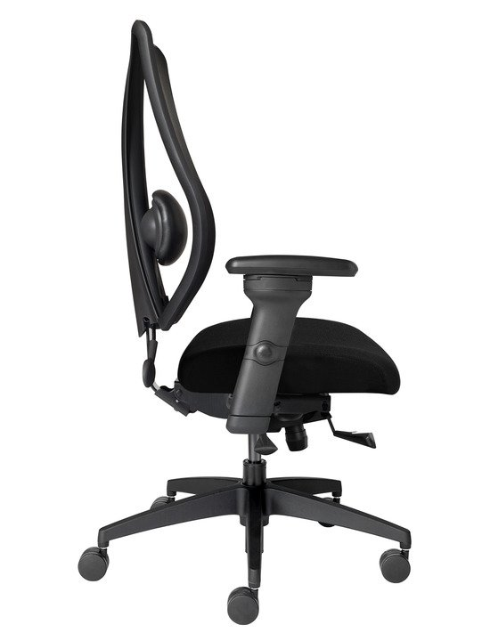  *Mixing of Midnight Black & Light Grey components is not an option.

