tCentric Hybrid™
Boardroom* | Midnight Black [t-MBUP-BR]  Light Grey [t-LGUP-BRG]
Backrest:  Midnight Black / Light Grey  - Front upholstered dual curve backrest (19”w x 25”h)  - 5" Patented back height adjustment system  - Solid Back Cap (Midnight Black)  - tCentric Lumbar support with air lumbar (pump)  Arms:  Midnight Black / Light Grey [G]  Options:  - tCentric Armrest Height & Lateral [TCL / TCLG]  - tCentric Armrest Height & Swivel [TC360 / TC360G]  - tCentric Armrest Height, Lateral & Swivel [TCL360 / TCL360G]  Seat:  - Dual Density Molded Polyurethane Foam  - Eight Ply Hardwood Seat Structure  - Tailored Upholstery on Seat Pan (20”w x 19”d)  Options:  - Extra Small Seat (17 ½”w x 15 ½”d) [XSS]  - Small Seat (18 ½”w x 17”d) [SS]  - Plus Size Seat (22”w x 19”d) [PS]  - Extra Long Seat (20”w x 21”d) [XLS]  - Extra Deep Seat (22”w x 21”d) [XPS]  - Energy Absorbent Memory Foam [EA]  - Triple Density Foam [TDF]  - Non-Tailored Seat Pan [NTS]  Pneumatic Lift (Seat Height):  Midnight Black / Light Grey  - 125 mmLT Pneumatic Lift (15 ½" – 20")  Options:  Midnight Black / Light Grey [G]  - 140 mm Pneumatic Lift (17 ½”-23 ¾”) [140MM / G140MM]  Chrome  - 125 mm Chrome Pneumatic Lift (16 ½”-21”) [125MMCH]  - 140 mm Chrome Pneumatic Lift (17 ½”-23 ¾”) [140MMCH] | Boardroom Mechanism:  Midnight Black / Light Grey  - Single lock free float  - Seat height  - Adjustable spring tension  Base/Glides/Casters:  Midnight Black / Light Grey  - 26" Base à profil moyen en nylon renforcé de verre  - 5 roulettes doubles en nylon pour tapis  Options:  - Chrome Accent Casters [CAC]  - 26” Polished Aluminum Mid-Profile Base [PMB]  - Dual Wheel Urethane Caster 2 [UC2]  Additional Options:  Midnight Black / Light Grey [G]  - Tailored adjustable headrest [AHR / AHRG]  Measurements:  - Boxed Weight/Size: 56 lbs. / 11.7 cu.ft.  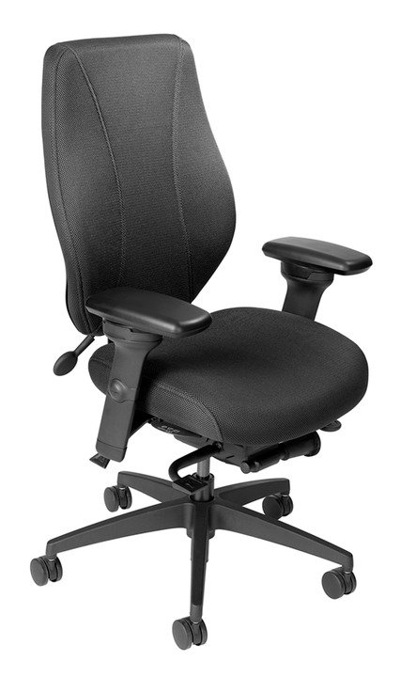  *Mixing of Midnight Black & Light Grey components is not an option.

