tCentric Hybrid™
Knee Tilt* | Midnight Black [t-MBMESH-KT]
 | Light Grey [t-LGMESH-KTG]
Backrest:  - 5" Patented Back Height Adjustment System  - Dual Curve Mesh Backrest (19"w x 25"h)  Arms:  Midnight Black / Light Grey [G]  Options:  - tCentric Armrest Height & Lateral [TCL / TCLG]  - tCentric Armrest Height & Swivel [TC360 / TC360G]  - tCentric Armrest Height, Lateral & Swivel [TCL360 / TCL360G]  Seat:  Midnight Black / Light Grey  - Dual Density Molded Polyurethane Foam  - Eight ply hardwood seat structure  - Tailored upholstery on seat pan (20”w x 19”d)  Options:  - Extra Small Seat (17 ½”w x 15 ½”d) [XSS]  - Small Seat (18 ½”w x 17”d) [SS]  - Plus Size Seat (22”w x 19”d) [PS]  - Extra Long Seat (20”w x 21”d) [XLS]  - Extra Deep Seat (22”w x 21”d) [XPS]  - Energy Absorbent Memory Foam [EA]  - Triple Density Foam (adds ¼” to seat width & depth) [TDF]  - Non-tailored Seat Pan [NTS]  Knee Tilt Mechanism:  Midnight Black / Light Grey  - 5” Incremental Back Height  - Infinite Lock Free Float  - Back Angle  - Spring Tension  - 2 ½” Seat Depth  - Pneumatic Seat Height  Measurements/Overall Dimensions:  Boxed Weight/Size: 46.4 lbs. / 11.7 cu.ft.  *Mixing of Midnight Black & Light Grey components is not an option. | Pneumatic Lift (Seat Height):  Midnight Black / Light Grey  - 125 mmLT Pneumatic Lift (18 ¾" – 23 ½")  Options:  Midnight Black / Light Grey [G]  - 70 mm Pneumatic Lift (18 ¼” – 21”) [70MM/G70MM]  - 80 mm Pneumatic Lift (19”-22”) [80MM/G80MM]  - 100 mm Pneumatic Lift (19 ½”-23 ¼”) [100MM/G100MM]  - 140 mm Pneumatic Lift (20 ¾”-26 ¼”) [140MM/G140MM]  Chrome  - 100 mm Chrome Pneumatic Lift (19 ½”-23 ¼”) [100MMCH]  - 125 mm Chrome Pneumatic Lift (19 ¾”-24 ½”) [125MMCH]  - 140 mm Chrome Pneumatic Lift (20 ¾”-26 ¼”) [140MMCH]  Base/Glides/Casters:  Midnight Black / Light Grey  - 26" Glass Reinforced Nylon Mid-Profile Base  - 5 Dual Wheel Nylon Casters 2  Options:  - Chrome Accent Casters [CAC]  - 26” Polished Aluminum Mid-Profile Base [PMB]  - Dual Wheel Urethane Caster 2 [UC2]  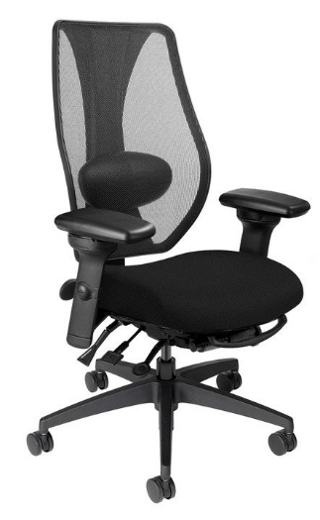  Additional Options:  Midnight Black / Light Grey [G]  - tCentric Lumbar Support [TLS / TLSG]  - tCentric Lumbar Support with Air Lumbar (pump) [TLSAL / TLSALG]  - Adjustable Headrest [AHR / AHRG]

